Chapter 5
OKUDEN
OKU IAI
(Tachiwaza)
(Final Tradition, Standing Forms)

Ipponme Yukitsure Form #1 "Traveling Companion"

You are being unlawfully taken away by two enemies on the left and right of you who are sandwiching you in between.

- Taking measure of the situation, you wait and let the enemy on the right get one step ahead of you.
- Executing nukiuchi with your right hand, cut the left shoulder of the enemy on the right with a left kesa cut, felling him.
- The enemy on the left is startled by this (he is one step ahead of you) and as he turns to face you…
- You execute furikamuri parrying from the right
- And facing towards the enemy
- Take jodan with both hands
- Execute kirioroshi from directly in front of the enemy.

In the traditional texts, the assumption is that you are attacked by the enemy on your right who is trying to cut you down, so you step your left foot out to the left side in order to avoid him.

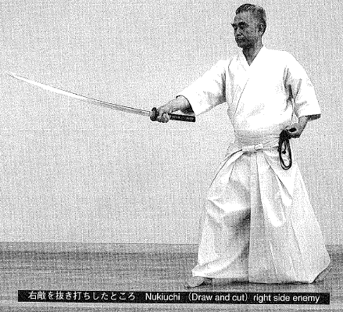

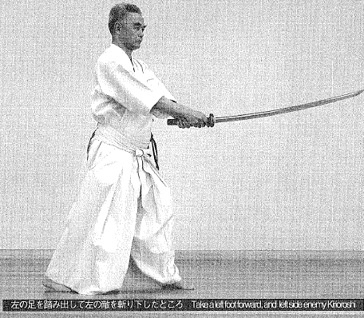
Nihonme Tsuredachi Form #2 "Traveling Companions"

Just as in the form, Yukitsure, you are sandwiched in between two enemies who are taking you along by force.

- Step your right foot out slightly to the right front
- Draw your sword towards the right horizontally with the blade facing outward (like the Japanese character "one".)
- As the kensen exits the koiguchi, thrust your sword into the right flank of the enemy on your left, who is slightly ahead of you.
- Retaining your foot position, rotate around, turning about 160 degrees to the right
- Meanwhile, the enemy on your right, who is one step ahead of you, turns toward you in surprise and you execute kirioroshi from jodan, directly down his center.

If the enemy on your left is directly to the left of you, you can also thrust directly to the left.
In the traditional texts, the assumption is that the enemy on the left attacks you so you avoid him by moving your body to the right.

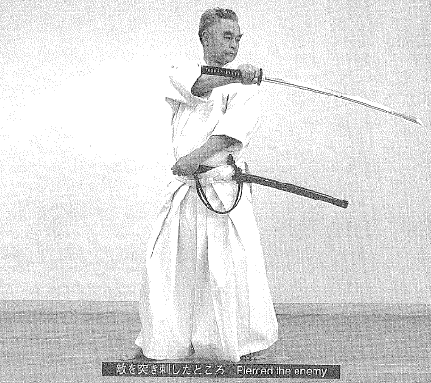

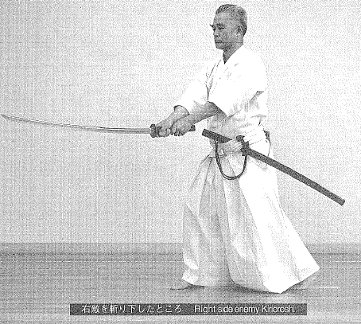

Sanbonme Somakuri Form #3 "Bound by Enchantment"

There are five enemies in front of you.

- The first enemy attacks from the from so you take one step back with your right foot, and with ukenagashi, parry the enemy's sword lo the left. Then, as you step the right foot forward, you cut the left side of the enemy's face with a returning blow.
- Stepping forward with the left foot, you cut through the enemy's right shoulder with a kesa
- Then returning the blade again, you step your right foot forward another step and cut through the left torso of the third enemy.
- Then step your left foot out one step and return the sword to horizontal position, use both hands to cut all the way through the torso of the fourth enemy from his right side.
- Advancing forward, raise the sword to jodan and execute kirioroshi directly from in front of the fifth enemy.

This form is not limited to five attackers. Think of this form as a response to a multiple opponent attack from the front.

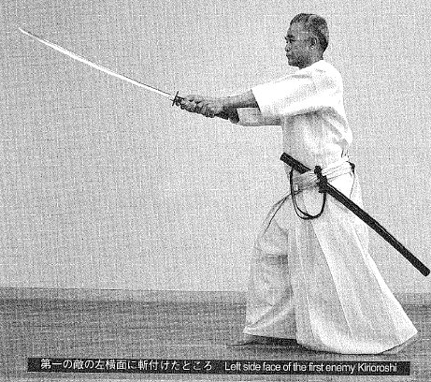

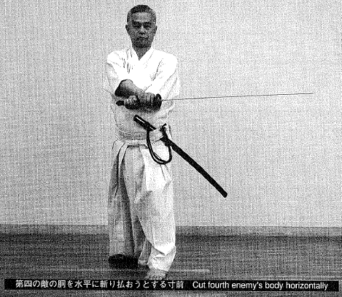

Yonhonme Sodome Form #4 “Stopping Them All”

You are passing through an area with many obstacles on both sides such as a narrow wooden bridge, an earthen embankment, a narrow street or stairs that make it difficult for you to turn around freely.

- Turning your hips fully to the left, you execute nukiuchi with your right hand only, performing kirioroshi through the enemy's shoulder and chest.
- You perform the same single-handed nukiuchi and cut the second and third enemy as well.
- Finally, you turn your hips to the right, re-orientating yourself to the front and perform chiburi and noto.

There are two methods of footwork.
- In response to the first enemy, step your right foot out (with the toes facing left), turning your hips to the left so that you assume a left hanmi; (the left toes are also facing to the left) then execute a single handed draw with your right hand and cut the enemy.
- Next, take your left foot and step it to the right side of your right foot (with the left toes still facing left) like a heron's foot; drop your hips as you step and execute the first noto. Then, just as was the case with the first enemy, step your right foot out to the right, and simultaneously draw and cut the second enemy. Repeat this sequence several times.
When cutting the enemy, always assume hanmi, turning your own body to the left, when facing the enemy.

In the traditional texts, Hanashiuchi is performed differently than described above. The left and then the right foot are stepped forward directly toward the enemy.

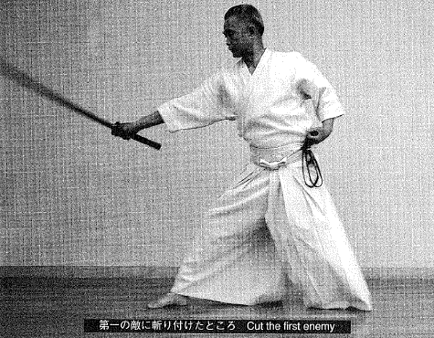

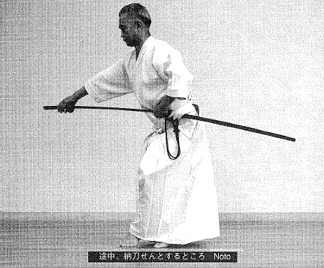

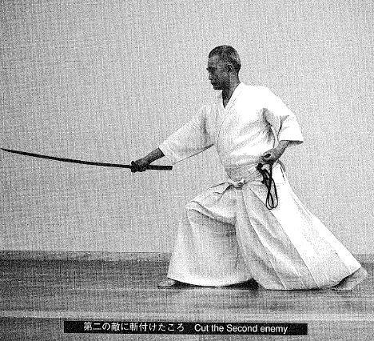

Gohonme Shinobu Form #5 "Stealth (Faithful Servant)"

The form name Shinobu (these characters meaning "Faithful Servant") may be also thought of as a play on words with the double meaning of Shinobu: to conceal or endure.

This form takes place in the dark of night. An enemy in front of you is advancing directly toward you.
- You dimly perceive the enemy and turn your body to the left, avoid directly running into the enemy who is advancing toward you.
- Sinking your body down, you take the tip of your sword and lightly tap the earth two or three times, creating a sound which seduces the enemy into striking-cutting at empty air.
- Step your left foot out to the left front diagonal and execute kirioroshi from jodan, felling the enemy.

This form takes place in a dark area so it is necessary to create the feeling of stealth and waiting for the proper moment.

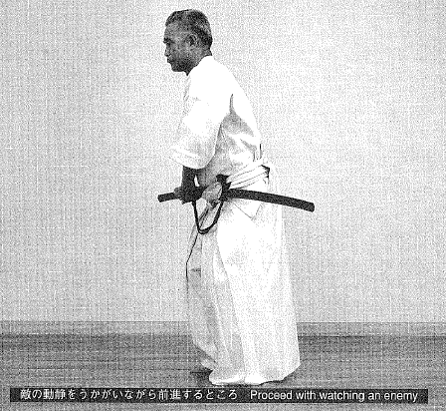

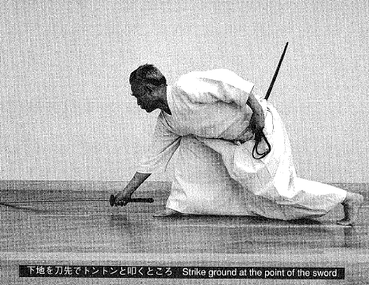

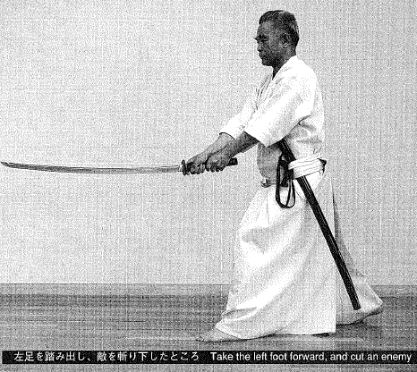

Ropponme Yukichigai Form #6 “Crossing Paths”

Two enemies approach you from the front, one behind the other.

- You step in between the two enemies and thrust your hilt directly into the face of the second enemy between his nose and upper lip. The action of tsuka-ate is done by thrusting both hands forward with the sword and saya extending together and butting the tsukagashira directly beneath the enemy's nose.
- Then swiftly pull the left hand back to pull the saya off and execute batto, turning your body to the left 180 degrees. As the enemy who has proceeded in front turns around, thrust through him with the blade left in a vertical upward position (just as it was unsheathed).

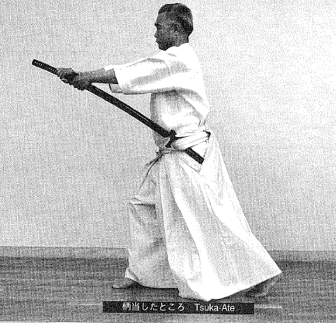

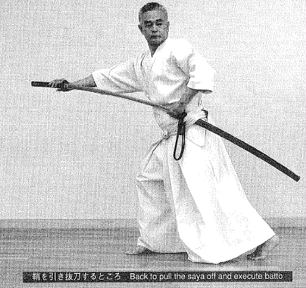

- Then again turn around 180 degrees to your right (leaving the feet where they are) and execute kirioroshi from jodan, felling the enemy you struck first.

It is also appropriate to imagine two enemies attacking you: one from the front and one from the back.

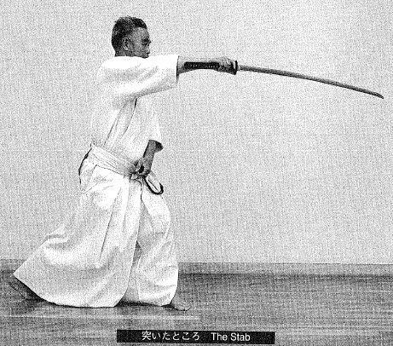

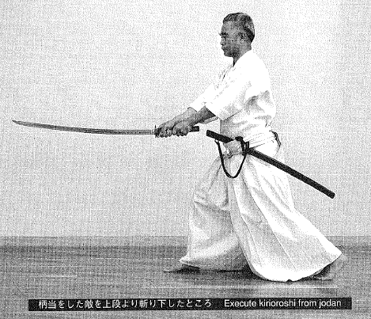

In other styles:
- You strike the enemy behind in the face, then execute batto as you turn around.
- In place of the thrust, you cut one enemy from jodan.
- Then turn around and cut down the second enemy whom you struck with the tsuka, with kirioroshi from directly in front of him.

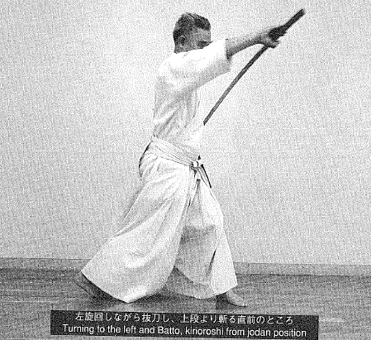

Nanahonme Sodesurigaeshi Form #7 "Brushing Sleeves"

There is a large crowd of people in front of you. Beyond this crowd, you spot an enemy.

- As you are walking, step the left foot forward and quietly draw the sword.
- Step your right foot forward and simultaneously bring your right fist above your left elbow (as if you are thrusting behind you with the blade of the sword facing up), draw your left fist across to beneath your right armpit so that your left and right arms are folded together across your chest.

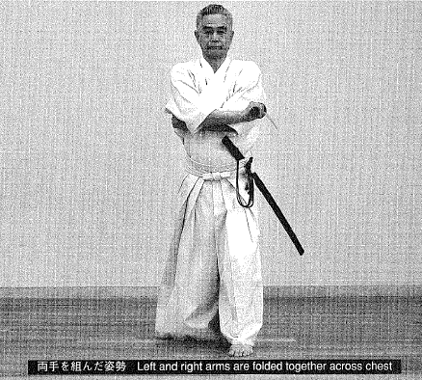

- Turning your upper body slightly to the rear in order to wind up, you then thrust your upper body forward, stepping your right foot forward and opening up both arms wide. At this time both elbows force an opening in the crowd (literally, "human fence").
- As your body emerges from the crowd you execute ukenagashi in a parry to the right hand side as you perform furikaburi to jodan and execute kirioroshi, felling the targeted enemy.

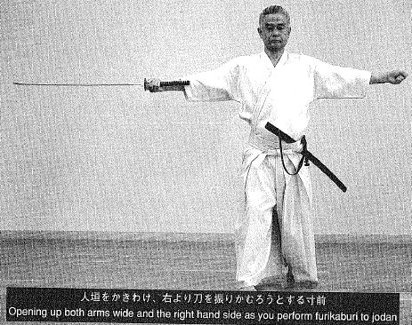
Happonme Moniri Form #8 “Entering the Gate”

Within the gate there are enemies (more than two of them).

- Step your left foot across the threshold of the gate (your body should be in hanmi toward the right). Turning the blade outward, draw your sword horizontally in front of your chest and stab the enemy inside of the gate.
- Leaving your feet in this position, turn 180 degrees to your right and cut the enemy who is behind you outside of the gate.

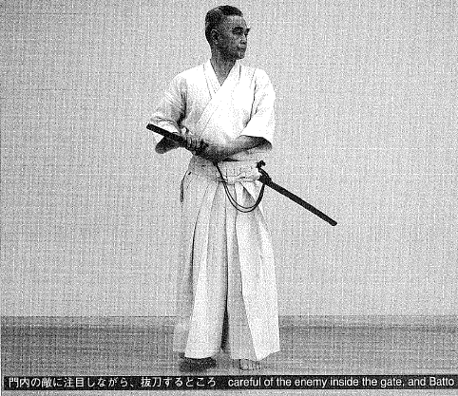

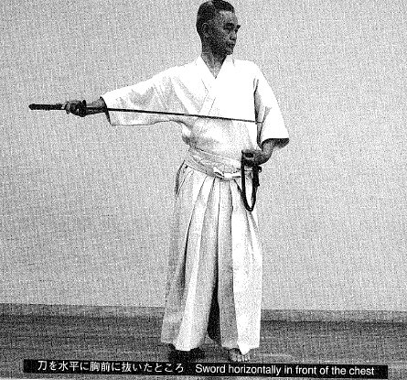

- Then again turn 180 degrees to your left and cut down one more enemy who is inside the gate.

This form entails stepping into the dead center of the gate and felling several enemies who are both inside and outside of the gale. This form should be taught as a sword technique that may be used when there is a beam or obstruction overhead that can easily catch your sword tip.

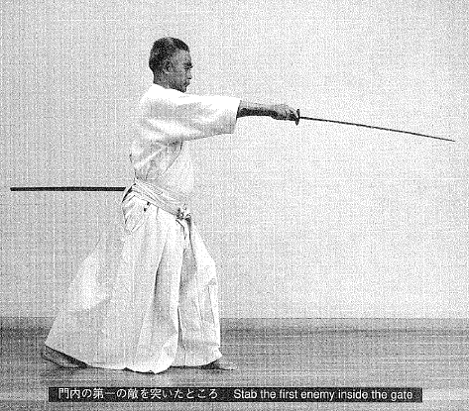

Kyuhonme Kabezoi Form #9 "Sticking to the Wall"

There are walls on the left and right of you. Alternatively, there are obstacles on both sides of you that make it difficult to wield your sword. There is an enemy in front of you.

- As you are walking (or after you stop is ok too) align your right foot with your left foot and rise up on your toes, drawing the sword upward to the left and executing furikamuri.

In this instance you need to execute a deep furikamuri with the kensen touching your back since space is restricted.

- Execute kirioroshi from jodan as if you were drawing a large circle. The kensen should end very low, close to the ground. You are still standing on your toes (balls of your feet).

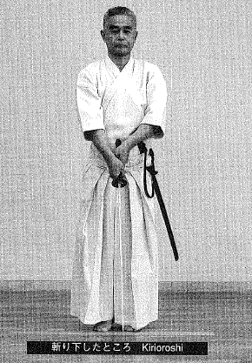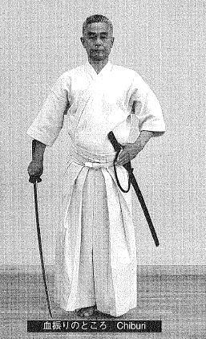

- Execute chiburi allowing the kensen to drop low to your side and close to your body. Perform noto at a steep vertical angle (from top to bottom).

As you finish resheathing the sword, drop both heels down.
In other words, this sword method is used for narrow places and you wield your sword within the width of your own body, without allowing it to protrude to the left or to the right.
In the traditional texts, this form is named, Hitonaka or "Among People", from the assumption that you are cutting down your intended enemy while in a large group of people without wounding by-standers unnecessarily.

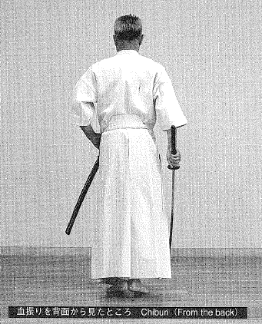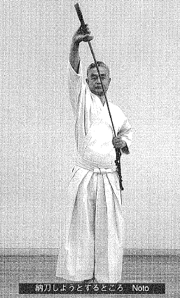

Jupponme Ukenagashi Form #10 "Receive&Let Flow"

As you are proceeding forward, your enemy approaches cutting directly from the front.

- Draw your sword diagonally to the right side while turning your left toes to the right.
- Stepping your right foot forward. Parry the enemy's sword.
- Turn your left toes to face the enemy, place your left hand on the tsuka; then, stepping so that the right and left feet are aligned, cut the enemy's shoulder.

According to conditions, it may also be appropriate to cut the enemy's neck.
In the traditional texts, the action of cutting across the hips is shown.
This form carries the same intention as the Shoden form, Ryuto; however, the difference in the standing form, Ukenagashi, is that the enemy approaches from the front.

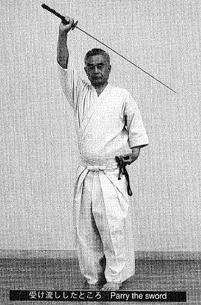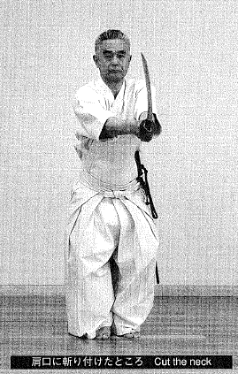

Juipponme Oikakegiri Form #11 "Pursue & Cut Down"

This is believed to be a form that Oe Sensei discarded when he re-organized the old tradition. It is generally not performed; however, it would be used often in actual warfare so I will explain it briefly here.
Pursuing an enemy who is fleeing, you take small steps forward, gradually drawing your sword. Just as you overtake the enemy you execute batto, cutting through the enemy's neck or arms or chest from the back. Then step forward and execute kirioroshi from jodan from above the enemy's head.
Generally, under the Bushido, or Samurai code of ethics, you would not pursue someone and cut them down from behind. However, this might occur under the circumstances of an assassination order from a superior that you must follow. It is under this circumstance that this attack method would be employed.

Junihonme Ryoshi Hikitsure Form #12 “Accompanied Journey”

This is also a form from the old tradition. It is usually not performed, but I will briefly describe it here for reference.
The enemy is to your left and you are taking him along by force. As you step your left foot out one step ahead, draw your sword with the blade facing outward (toward the enemy) and hold it ready at the your left flank. Take a large step out with your right foot and as your body steps out front as if to slide by him, cut the enemy's right arm. Then maintaining the same foot position, turn to your left to face the enemy and cut down the enemy from jodan.
When the enemy has proceeded one step ahead of you, draw your sword so that the enemy does know it; then, putting your full weight behind the sword, step out one large step with your right foot and drive your body and the sword directly into the enemy, pushing and drawing the blade through his arm and his chest.
This is also performed as a result of a secret order from a superior and would be used against an enemy of considerable strength, without him becoming aware of your actions.

Jusanbonme Itomagoi Form #13 "Farewell Visit" (3 forms)

This is the only form in the Oku lai compendium that is performed from seiza.
This is another form performed at the command of a superior. At the order of your superior, you pay a visit to the person who is supposed to be your enemy. As you begin the mutual aisatsu (greeting or bow), you perceive the enemy's intent to strike you and draw your sword in the middle of the aisatsu, cutting him down with kirioroshi.
There are three actions.
1. Sit in seiza facing the front and lower your head slightly (as in a silent bow); then, without allowing time to exchange greetings, swiftly draw your sword with your eyes still cast down and cut the enemy directly from the front with kirioroshi from jodan.
2. Place both hands on the floor and lower your head low; then, swiftly execute batto and cut the enemy down as he has his head bowed.
3. Place both hands on the floor and bow all the way down; then as you are rising, execute batto and cut the enemy as he is raising his head.

As stated before, Itomagoi has three different versions. In general, you would choose the most useful and practical method in accordance with the tone and movement of the enemy.

